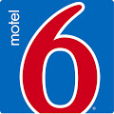
Motel 6 $39.59 per night/ 1 person
200 Commerce Drive $44.99 per night/ 2 people
I-83 at Limekiln Rd. $47.69 per night/ 3 people
New Cumberland, PA 17070 $50.39 per night/4 people
Call 1-800-544-4866 and book under Clean Break Group #GPGQ2O5B6Q by March 22, 2019 to get these rates which include the AKC discount as shown on NAFA’S website. The prices do not reflect the tax. Rooms Blocked, No Pet Fee, 2 Pets per Room
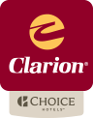
Clarion $89.00 per night two Queen beds
148 Sheraton Drive No Pet Fee
New Cumberland, PA 17070 Make reservations and book under Clean Break Flyball(Yellow Breeches Sports) by
March 22, 2019, Rooms Blocked- Call the Hotel directly at 717-774-2721 to get
discounts and Pet Fee waived. Do not try to book on line or with the 800 number.
The Clarion is a 3 Star Hotel and your stay includes free Full Hot Buffet Breakfast,
Indoor pool.

Other hotels at the same exit include Best Western (717-774-4440) and Scottish Inn (717-774-5990), both accept pets.
The only Red Roof & La Quinta Inns in the area are about 10 miles away (approx. 20 minutes) if you want to use the NAFA Red Roof Discount or La Quinta Discount.
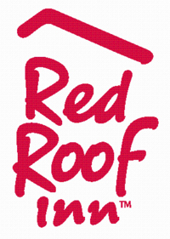
NAFA is pleased to announce special hotel rates for competitors.
North American Flyball Association members, receive a 20% discount at any Red Roof Inn Nationwide!
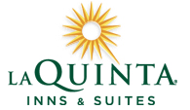
USE VP# 619263 WHEN BOOKING TO RECEIVE THE DISCOUNT! https://www.redroof.com/partners/nafa_members/

North American Flyball Association members, receive a 10% discount at any La Quinta Inns & Suites Nationwide! Including No Pet Deposits and Complimentary BrightSide Breakfast.

USE Discount Code NAFAFB2 WHEN BOOKING TO RECEIVE THE DISCOUNT!
Visit http://www.lq.com/en/navigation/findandbook/speciality-page.html?cobrand=NAFAFB2&stop_mobi=yes for additional information
La Quinta Inn & Suites
130 Limekiln Rd.
New Cumberland, PA 17070

